1. The firmware version must be above R3.42.053. Please use programming software version which is above CPSp1_V1.99.
2. Please use the new data.

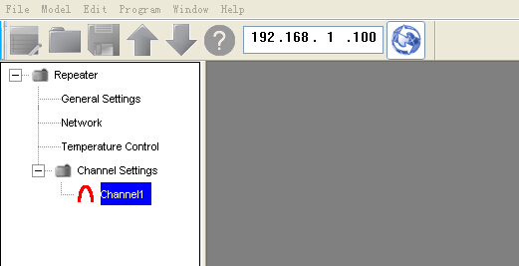

1. Please set device ID for each repeater in General Setting. The device ID must be different for each repeater in IP site connected system.

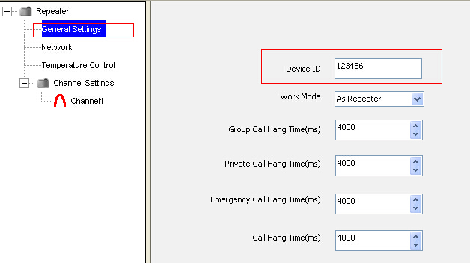

1. Please program the channel information for the repeaters you will use.

Normally, the working frequency is different for your three repeaters.

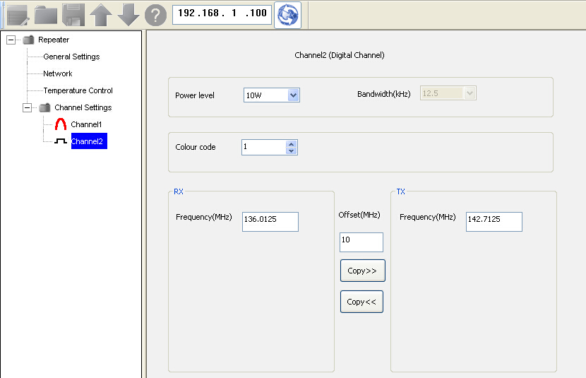

Note: The IP site connected function only be supported in digital mode.

1. Then go to network to set IP information.

In the IP site connected system, one of repeaters is used as master. Others are used as peers.

* For the master repeater, please refer the follow steps to set it.

1. Please select the IP to “static IP”. The master repeater only can use static IP.

Then set the unique IP address for it.

|  |  |  |
| --- | --- | --- |
| **Parameter** | **Value Range** | **Description** |
| DHCP | Default: Unchecked | Repeater's DHCP. |
| Static | Default: Checked | Repeater's Static IP address. |
| Local IP | e.g. 192.168.1.100. | Repeater's IP address. |
| Mask | e.g. 255.255.255.0. | Repeater's sub network mask. |
| Gateway | e.g. 192.168.1.1 | Repeater's gateway. |
| DNS | - | Repeater's Domain Name Server IP address. |

1. For the AIS parameters, you can use the defaulting setting.

Please refer the following form to check the explanation for each option.

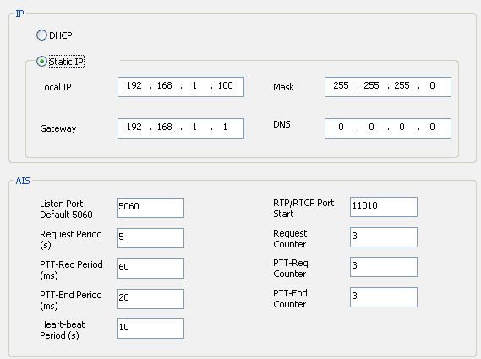

|  |  |  |
| --- | --- | --- |
| **Parameter** | **Value Range** | **Description** |
| Listen port | Range: 1024-65535  Default: 5060 | AIS traffic is transferred on this port. |
| RTP/RTCP Port Start | Range: 1024-65535  Default: 11010 | AIS supports 4 SIP group calls at the same time, and each group call has a separate RTP/RTCP pair ports. The 4 group calls use continuous ports. This parameter sets the first port of the continuous ports. |
| Request Period | Range: 1-20(s)  Default: 5s | Interval of re-sending request. |
| Request Counter | Range: 1-7  Default: 3 | Amount of re-sending request. |
| PTT-Req Period | Range:60-360 (ms)  Default: 120ms | Interval of re-sending PTT request. |
| PTT-Req Counter | Range: 1-5 Default: 3 | Amount of re-sending PTT request. |
| PTT-End Period | Range:10-120 (ms)  Default: 20ms | Interval of PTT ends |
| PTT-End Counter | Range: 1-5. Default: 3 | Amount of PTT ends |
| Heartbeat Period | Range:1-20 (s) Default: 10s | Call heartbeat interval. |

1. Site Link Configuration

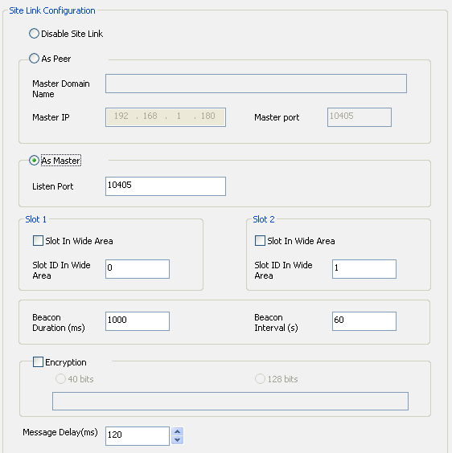

In the IP Site Link Configuration, please click “as master”.

And then program the listen port.

For the slot0 and Slot1, if you enable “slot in wide area”, this slot will work in IP site connected system. And if you disable it, this slot will work in local area. (This slot will work in single repeater mode.)

Encryption: If you enable encryption for one of repeater in IP site connected system, then all the repeaters in this IP site connected system must be enabled and set the same encryption keys for them.

Please refer the following form to check the explanation for each option.

|  |  |  |
| --- | --- | --- |
| **Parameter** | **Value Range** | **Description** |
| Disable Site Link | Default: Unchecked | If selected, the repeater doesn't connect to the Site Link system, and the repeater works alone. |
| As Peer | Default: Checked | The repeater role in the Site Link. If selected, the repeater works as a normal peer, and it should register with the master when powering up. |
| Master Domain Name | - | Repeater can get the Site Link's master IP address from DNS through this parameter. This is the domain name of repeater's Site Link Master device.  **Description:**  The parameter can be set only when “As Peer” is selected. |
| Master IP | e.g. 192.168.1.180 | Master IP address. Repeater can connect to the Site Link through this address.  **Description:**  The parameter can be set only when “As Peer” is selected. |
| Master port | Range: 1024-65535.  Default: 10405 | Master device's port. The master of the Site Link listens on this port.  **Description:**  The parameter can be set only when “As Peer” is selected. |
| As Master | Default: Unchecked | The repeater role in the Site Link. If selected, the repeater works as master, and all the other peer devices should register with this repeater when they connect to Site Link. |
| Listen Port | Range: 1024-65535  Default: 10405 | If the current repeater acts as Site Link Master, this port is used to listen to the traffic from other peer repeaters.  **Description:**  The parameter can be set only when “As Peer” is selected. |
| Slot In Wide Area | Default: Unchecked | If checked, the current slot is used in wide area network. Otherwise, this slot is used for local repeater only. |
| Slot ID In Wide Area | Range: 0-16777215.  Default: slot 1 is 0, slot 2 is 1 | In Site Link, the TX repeater sends traffic (voice, data or signal) to the RX repeater through a Wide Area Slot. This parameter sets the Slot ID for the Wide Area Slot. |
| Beacon Duration | Range: 00-7000 (ms)  Default: 000ms | In a Site Link Network, the repeater should transmit a dedicated beacon signal periodically so that the terminal radios can be notified of the existence of the current Site Link system. In addition, the terminal radios can evaluate the signal strength (RSSI) through the beacon signal. This parameter sets the beacon duration for each beacon transmission. |
| Beacon Interval | Range:10-600 (s)  Default: 30s | In a Site Link Network, the repeater should transmit a dedicated beacon signal periodically so that the terminal radios can be notified of the existence of the current Site Link system. In addition, the terminal radios can evaluate the signal strength (RSSI) through the beacon signal. This parameter sets the beacon interval transmitted by the repeater. |
| Encrypt | Default: Disable | If checked, the network traffic will be encrypted.  Used for wide area transferred traffic encryption. The encryption algorithm can be selected as ARC4 or AES. |
| Message delay | Range:60-960 (ms)  Step:60 ms  Default: 120ms. | The repeater shall be able to cope with variable jitter as expected in a wide area network, and to cope with high-latency connections (up to 1000ms), such as those found on satellite links. This parameter is the maximum time that the repeater waits for, and the message is valid before timeout or dropping it. |

* Please refer to following steps to configure your peer repeaters.

1. Please set the unique IP address for each peer repeater.

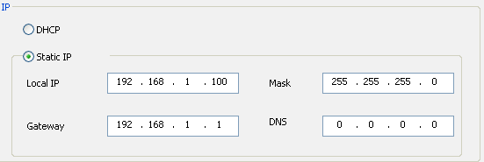

The peer repeater IP can be set to DHCP or Static IP.

1. In the IP Site Link, select “as peer”. Note, here you must set the master IP address and master port which you set it for the master repeater.

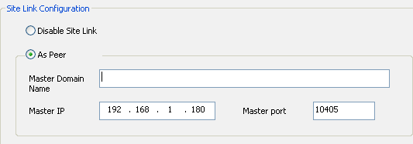

Please set the other parameters same with master repeater.